Kotlin

Kotlin is the modern programming language. That runs on java virtual machines (JVL).

Kotlin supports both object oriental programming language.

Language fundamentals

* Comments in kotlin

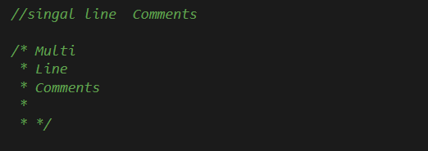

* Displaying output the console

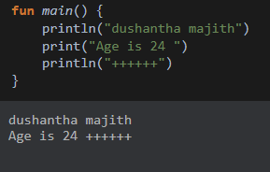

Data type is kotlin

1. Complete Number and Integer :- Byte,Short,Int,Long
2. Floating point/Decimal number :- Float, Double
3. Boolean :- Boolean
4. Character :- Char
5. String values :- String

For an Examples:-

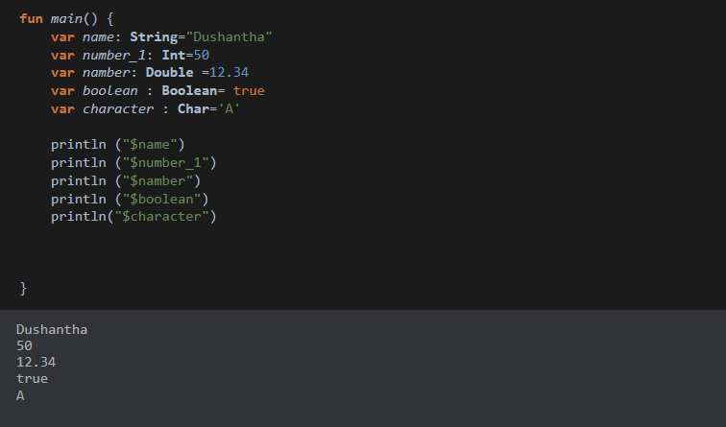

Lazy Initiazation

* Lazy variable is initiazaed only when it is accepted for the first time.

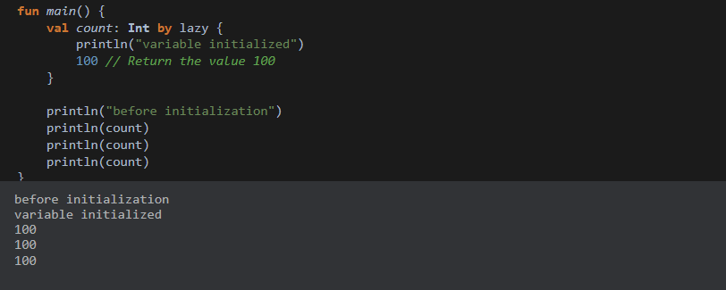

Null able variables

* Generally variable in kotlin can’t be a assign with null values to make variable in null able we need to use null able notation ( ? : ) went declare in variable when accessing null able variable we need to use Elvis operation to specify the default value for the variable it is a null.

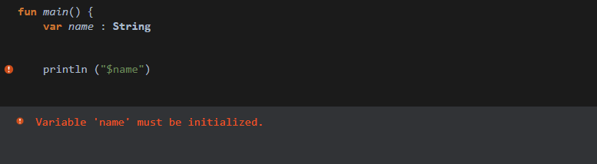

We should be a value assign the name(example) variable in but we will have to do the variable declaration we use null able variable.

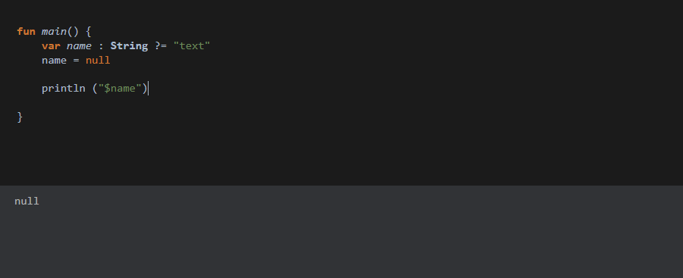

Variable is kotlin

There are two variable using kotlin programming

1. Immutable variables

• These variable cannot be changed once they are initialization.

* The value of a “val” variable

For an Example:-

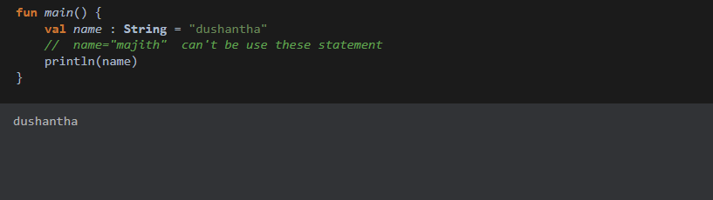

1. Mutable Variables

* These variables can be changed after they are initialized.
* The value of a “var” variable

For an Example:-

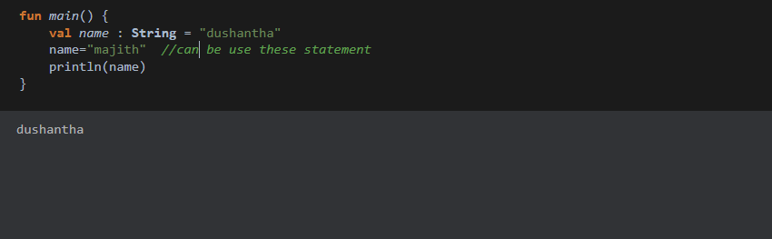

Function is kotlin

* It function of doesn’t return in values we need to use unit as a return type or can declare the function without mentioning return types.

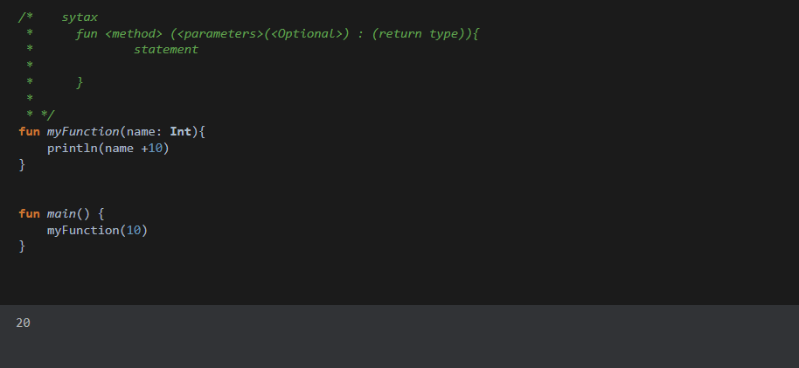

Example: - Create the kotlin function to accept use name and age as parameters to display greeting massage to the user on their birthdays.

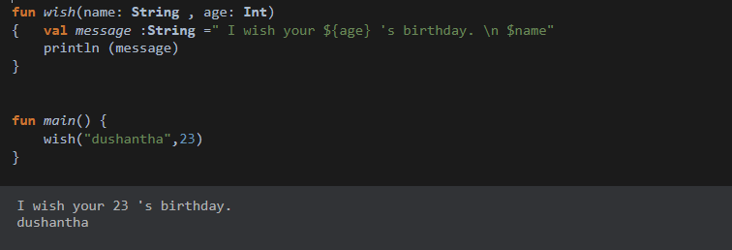

Example : - Create the kotlin function to accept bill Amount discount rate and tax rate as parameter and return final bill amount based on the following use 0.00 as the default value for discount and to rates.

*Final_bill =bill_Amount-(bill_Amount*discount_rate) + (bill_Amount*rate)*

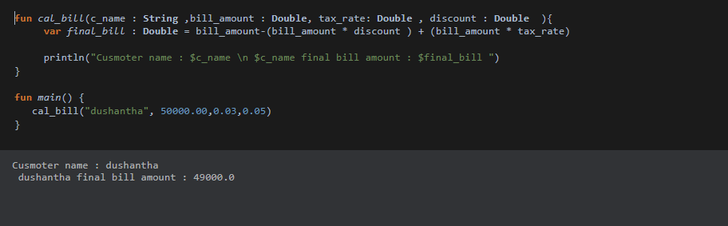

Example: - Create a function to accept customer name and units consumed as parameters to return a String mentioning the bill summary .

*Bill amount = units consumed *25.00*

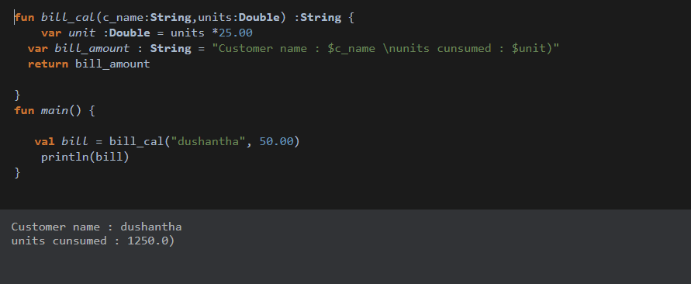

Selection statement

Example: - Create a kotlin function to accept assignment marks and exam marks as parameter and return the result of the student as String. Return pass if final marks >= 60 return fail if final marks < 60

*Final marks = assignment marks *0.4 + exam marks*

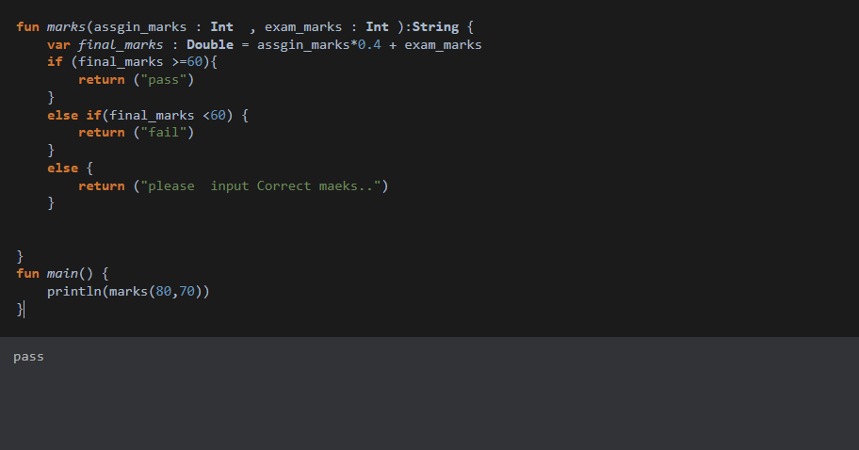

Example:- change the previous function to return final result String based on the following.

* If final marks >=60 result =Distinction
* If final marks <60 result = General
* If final marks <40 result = fail

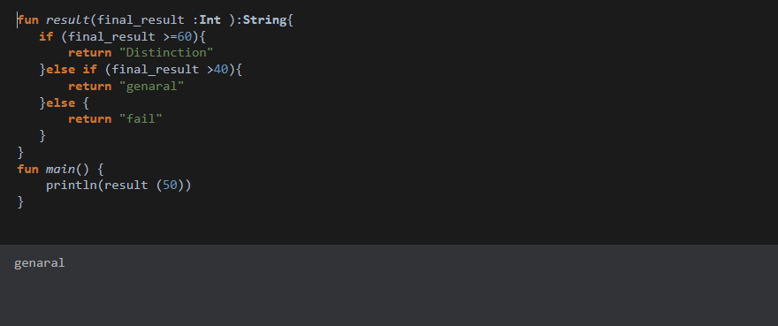

Range in kotlin

Range allows developer to check whether a the value false in between a range

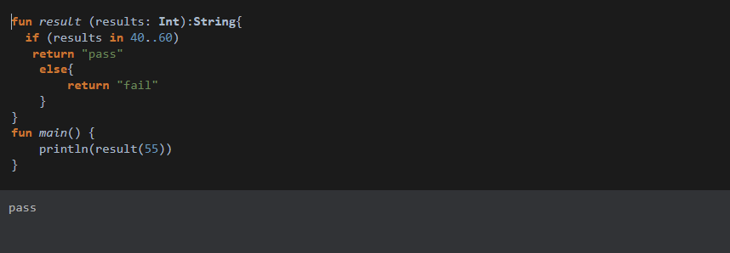

When statement

Example: - Create the function to accept bill amount as a parameter to return discounted bill amount according to the following criteria using when statements and ranges

* If bill amount >=1000.00, discount rate =0.5
* If bill amount >=5000.00 discount rate =0.10
* If bill amount 5000.00< and > 10000.00 discount rate =0.05
* If bill amount > 500 not discount

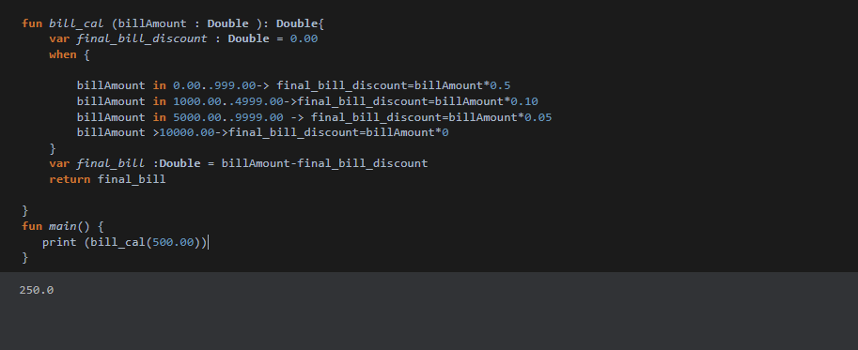

For loop

Example: - create a kotlin program to print numbers between 20 to 50 using a for loop

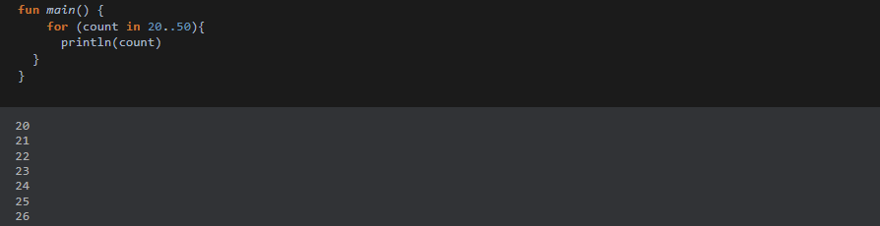

Down To

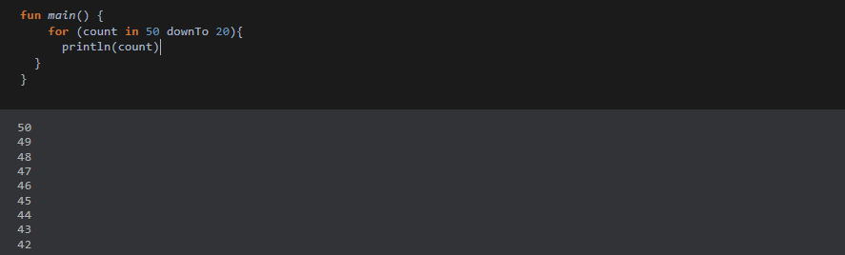

Example:- create a kotlin program to print multiple of 5 starting form 50 to 100

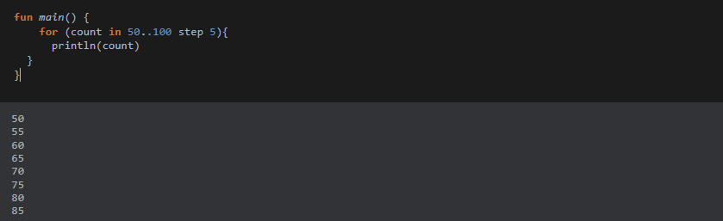

Example:- create a kotlin program to accept an integer number as a parameter and return whether that number is a prime number or not.

**Array in kotlin**

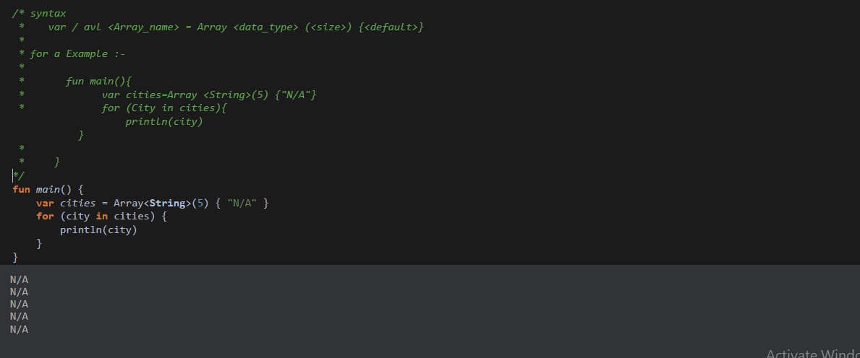

**Array using form method**

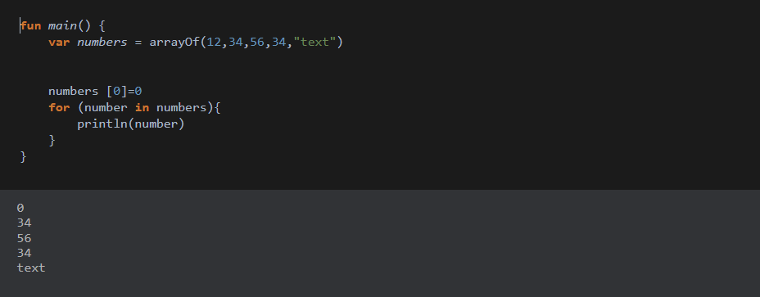

For an example:-

Create the kotlin function to store 45, 56,56,56,76, in to an array and display the total, Average, maximum and minimum value from the array.